Executive Summary
Three systemic risks are driving labor cost inflation and compliance exposure: $314,550 in preventable overtime, 997 unresolved timekeeping anomalies, and 97 student workers nearing thresholds that trigger benefits eligibility and up to 4x cost increases.
Top Operational & Compliance Risks
- Overtime Inflation: Overtime costs total $314,550 and 13% of payroll, with 92% concentrated in Dining and Custodial. Instances of workers exceeding 80 hours per week reflect unionized structural scheduling constraints. This is driving sustained reliance on $37.50 overtime instead of $19.17 student labor, a 96% cost premium. The absence of Sept 2026 Travel Market Symposium staffing plan further amplifies this exposure to uncontrollable overtime during peak.

- Unresolved Timekeeping Anomalies: There are 997 unresolved timekeeping anomalies, including missed punches, overnight shifts, and suspected rounding manipulation, which spiked in Feb–Mar 2026. This Kronos’ weak validation control increases the risk of paying for unverified hours.

- Threshold Breaches: 97 student workers are nearing the 19-hour weekly cap, and one has exceeded the 950-hour lifetime threshold. This breach triggers benefits eligibility or reclassification with up to 4x cost impact. This is further compounded by a 30% absenteeism in Events, accelerating threshold exposure.
Recommendations
- By June 15, 2026, GM and Director, catering Services will craft staffing plan for upcoming Symposium. The plan pre-assigns two additional student workers per shift across Custodial and Dining and as well as validating assignments against the 19-hour cap. Adding two student workers per shift at $19.17 per hour for the six-day event costs approximately $1,840 in additional labor, reducing overtime cost by 98%.
- HR should clear all 997 open timekeeping anomalies and track resolution in the HR Compliance dashboard. From May 2026 onward, open anomalies should remain below 20 per pay period to reduce overpayment risk and control labor cost inflation.
Limitation of the Analysis
W2W and Kronos do not have a link, hence fuzzy matching was used which linked 156 of 210 employees and leaves 54 unmatched, likely understating absenteeism. Data starts July 1, 2025, so pre-period hours are missing, and the 1,000-hour threshold reflects a partial view.
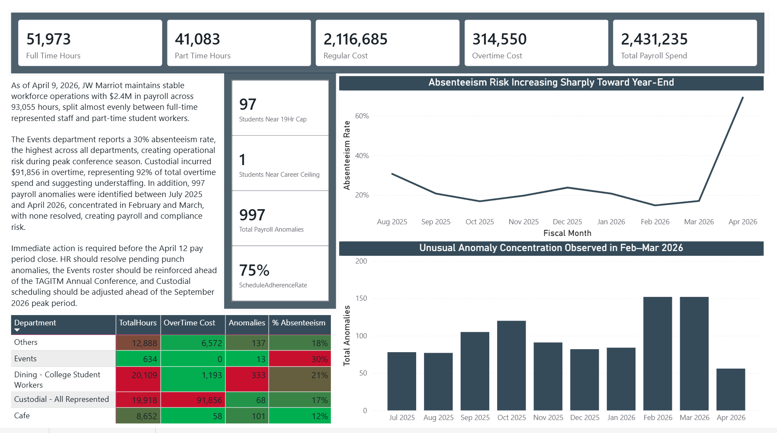
Appendix 1: Executive Summary.

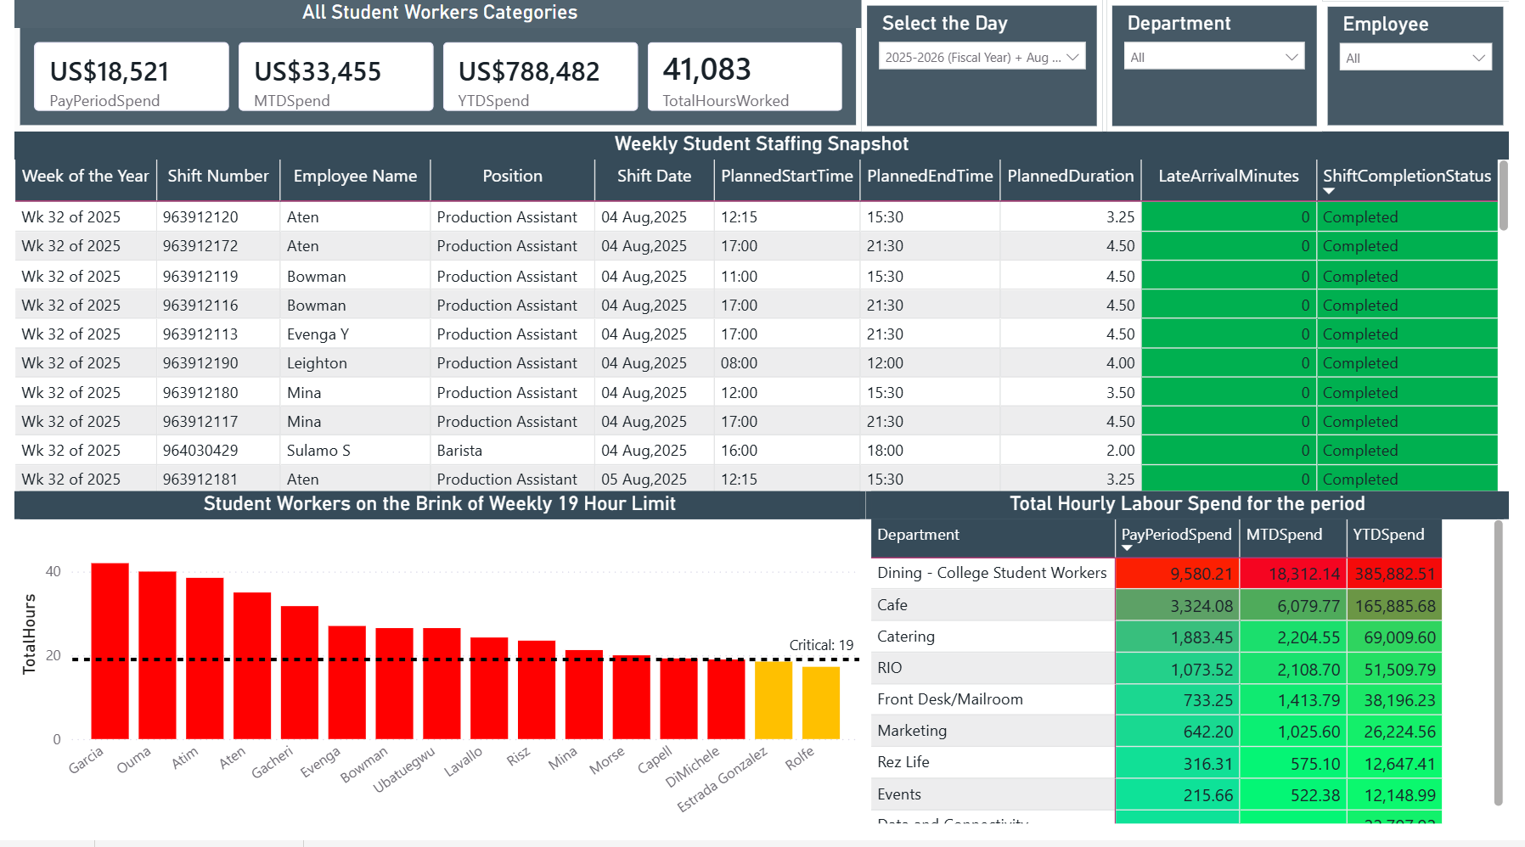
Appendix 2: Department Manager Dashboard

Appendix 3: HR Compliance & Punch Audit
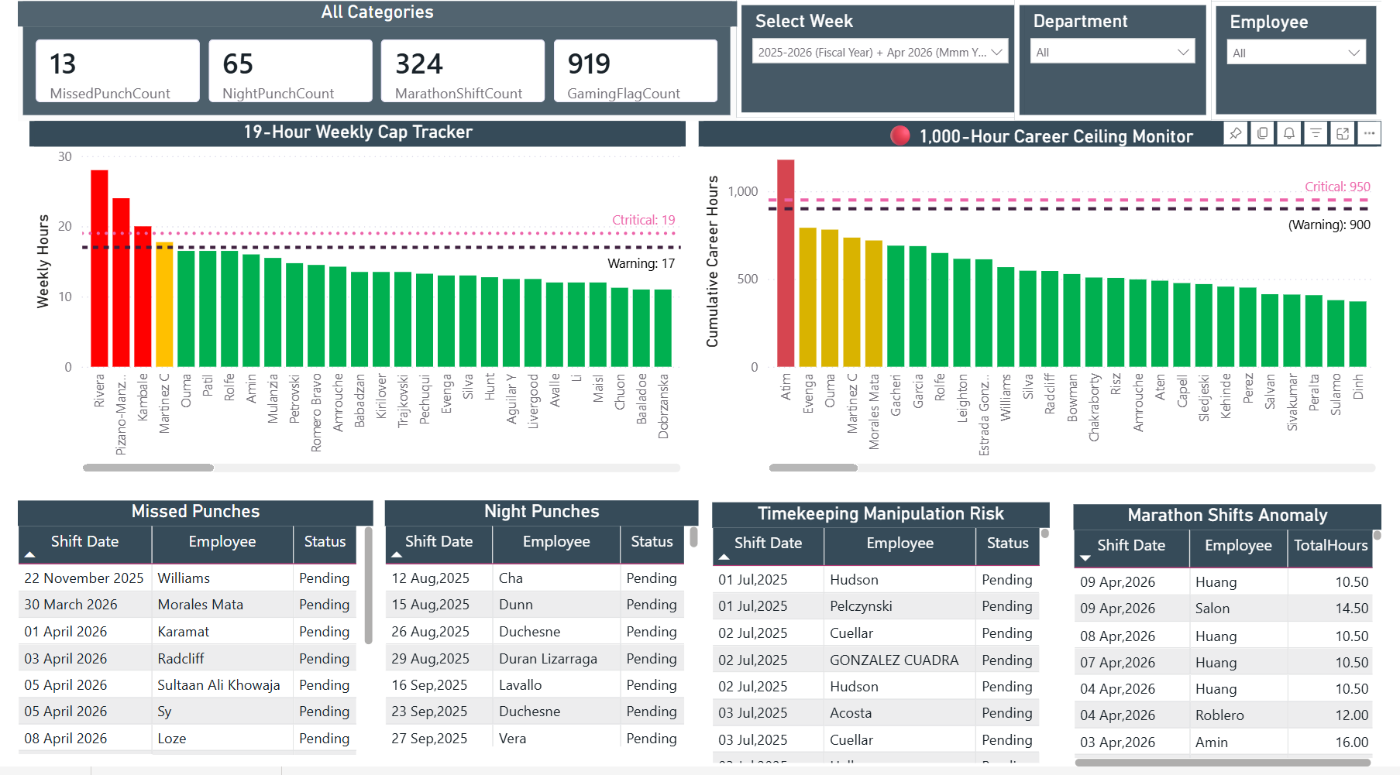

Appendix 4: Overtime Tracking
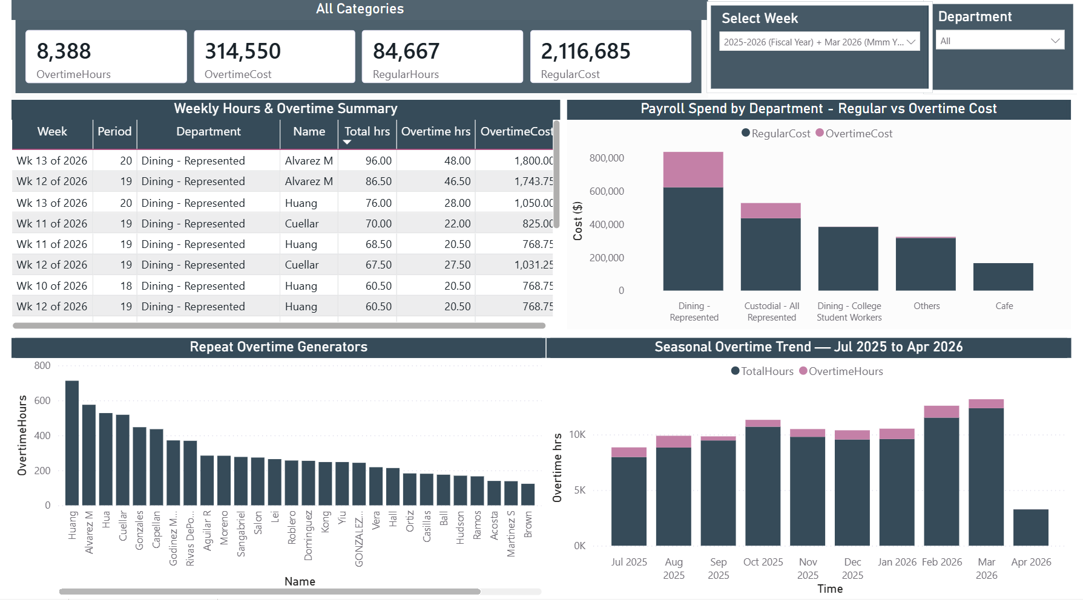

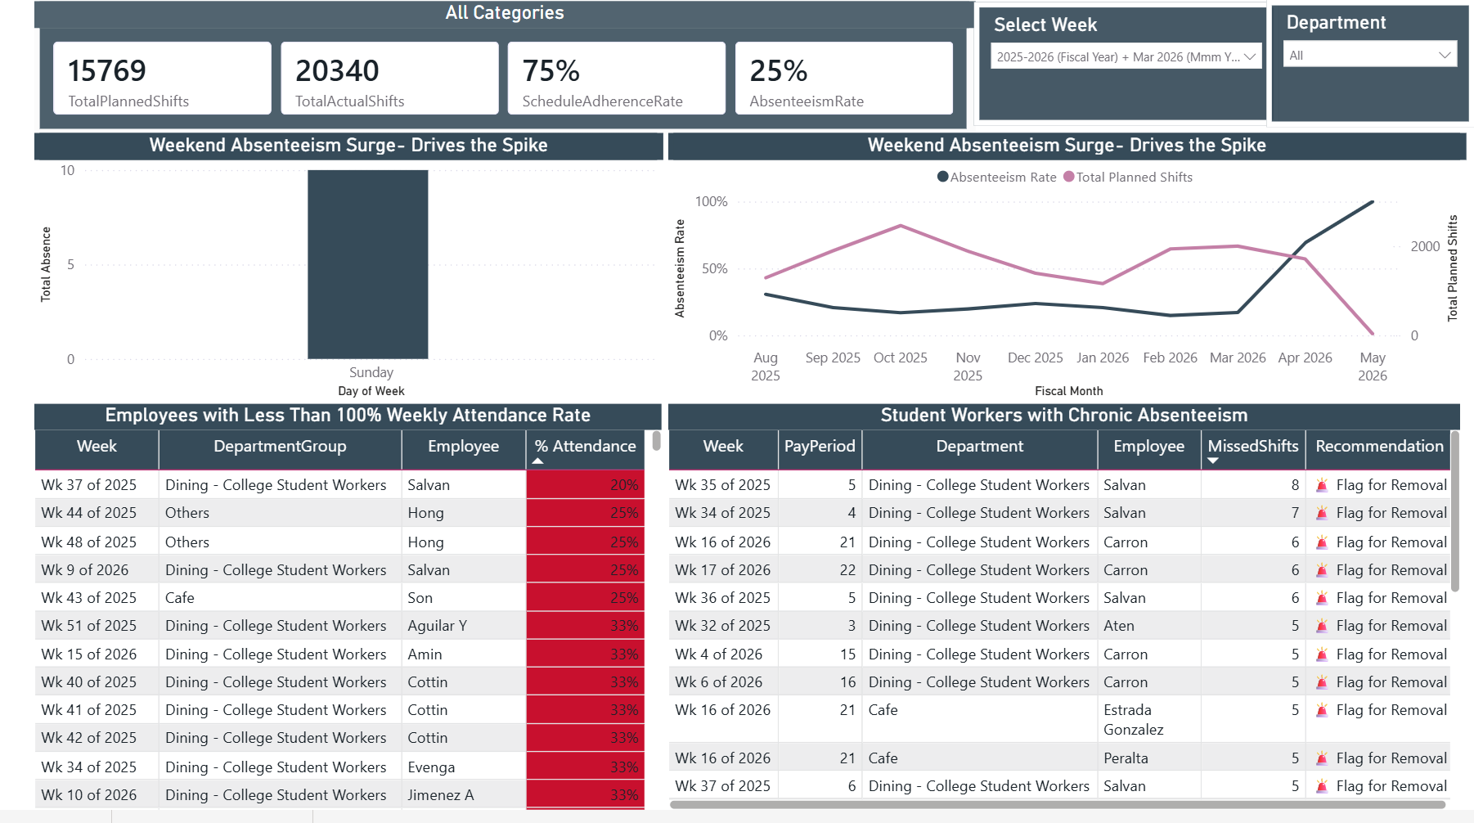
Appendix 5: Absenteeism & Schedule Adherence

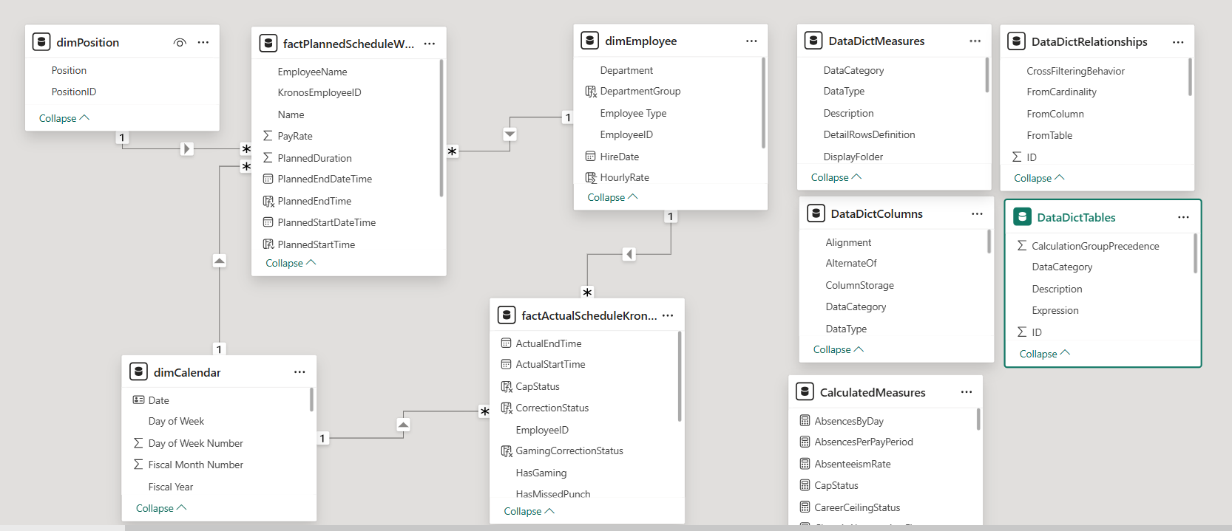
Appendix 6: Semantic Model

